Norfolk County Council proposes to make a Temporary Traffic Regulation Order (the “Order”) (NTRO9806) affecting the C420 Paston Road from its junction with C636 North Walsham Road for 1700m north-eastwards (the “Road”) in the Parish of Paston to facilitate blockage clearing works, the Road will be temporarily closed (except for pedestrian access) for the duration of the works/period the closure is necessary which is anticipated to be between 20:00 and 06:00 from 4th to 8th August 2025, but may continue to be closed/restricted until the 19th September 2025 where the closure is still required beyond the anticipated dates.

Alternative route is via: Paston Road, B1159 Bacton Road, C419 Hall Farm Road, C418 Church Road, C419 Sandy Lane, C636 North Walsham Road (Witton, Paston, Bacton).

The works promoter for this restriction/closure is: BT

Vehicular access will be permitted to a final destination in the Road where signs indicating such access is possible and permitted are in place.

The Order shall automatically revoke on the completion of the works when the closure is no longer necessary or otherwise on the 19th September 2025 without further notice.

If necessary, the restriction could run for a maximum period of 18 months from the date the Order is effective.

A person who contravenes, or who uses or permits the use of a vehicle in contravention of the closure imposed by the Order shall be guilty of an offence.

Penalty: £1000 maximum fine on conviction and/or endorsement for contravention.

In the event of the start date being delayed the new start date will be displayed on site in advance.

Full details on the closure are available at https://one.network. Any enquiries that cannot be answered on the one.network website should be directed to the North Area Streetworks (Community and Environmental Services Department) contactable by telephone at 0344 800 8020 or email at streetworks@norfolk.gov.uk

Dated this 25th day of July 2025.

Katrina Hulatt
Director of Legal Services (nplaw)
County Hall
Martineau Lane
Norwich
NR1 2DH

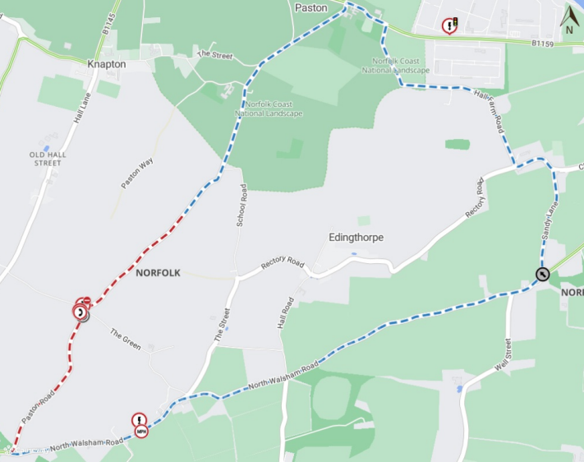
Imagery © 2025 MapTiler | Imagery © 2025 Hexagon | © MapTiler © OpenStreetMap contributors

